**Sustainable Development Goals A Global Visual Journey**

**Problem Statement:**

ABC Company aims to leverage the Sustainable Development Report 2023 dataset to identify priority areas for sustainable development interventions within its operations and supply chain. By analyzing sustainability scores, regional classifications, and progress towards SDGs across various countries, ABC seeks to align its practices with global targets, strategize actionable steps for improvement, and foster accountability through transparent reporting.

Through data-driven insights, ABC Company aims to drive meaningful progress towards sustainability while also contributing to the broader global agenda of sustainable development, fostering innovation, collaboration, and positive societal impact.

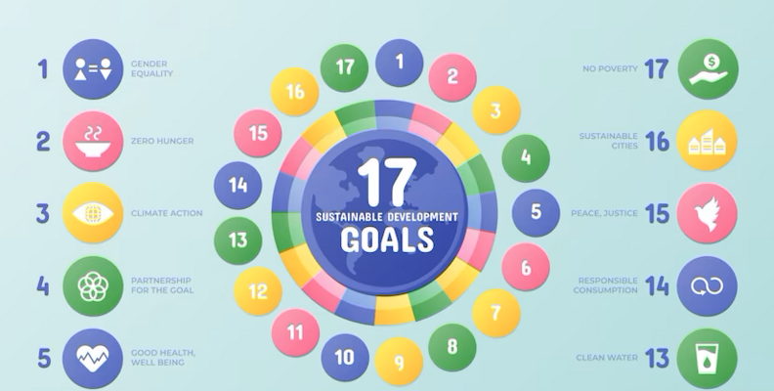

**Objective:**

An objective is a specific, measurable, and time-bound goal or target that an individual or organization aims to achieve. Objectives are typically set to guide actions and decision-making towards desired outcomes. They are often a part of broader goals and help to clarify what needs to be accomplished within a certain timeframe. Objectives should be realistic, achievable, and relevant to the overall mission or purpose, providing a clear direction for efforts and resources.

**Task:**

* The objective of the project is to utilize the Sustainable Development Report 2023 dataset to create data visualizations depicting Goal Scores by Country.
* This aims to identify priority areas for sustainable development interventions and benchmark progress towards Sustainable Development Goals (SDGs).

**Dataset**: [Link](https://www.kaggle.com/datasets/sazidthe1/sustainable-development-report)

**Solution Development Procedure:**

* Once we load the data into Tableau Desktop.
* Drag Country to Columns and Goal 1 score to Rows and Specify Goal 1 score to filters to remove null values.

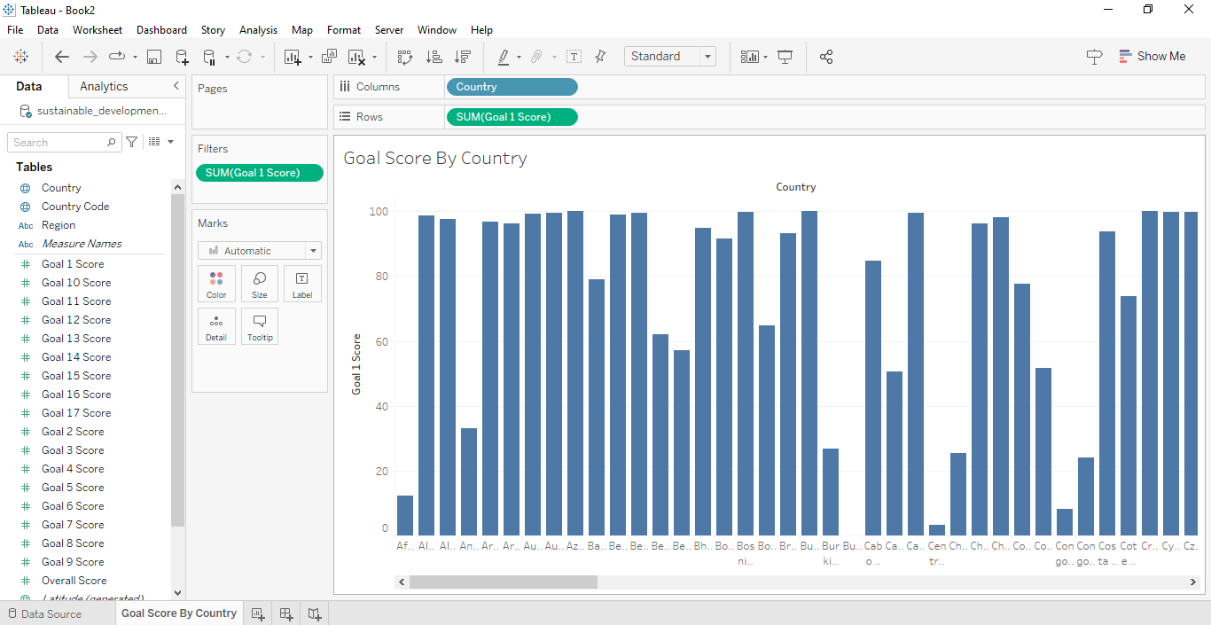

* Also Drag Overall Scores to Rows.

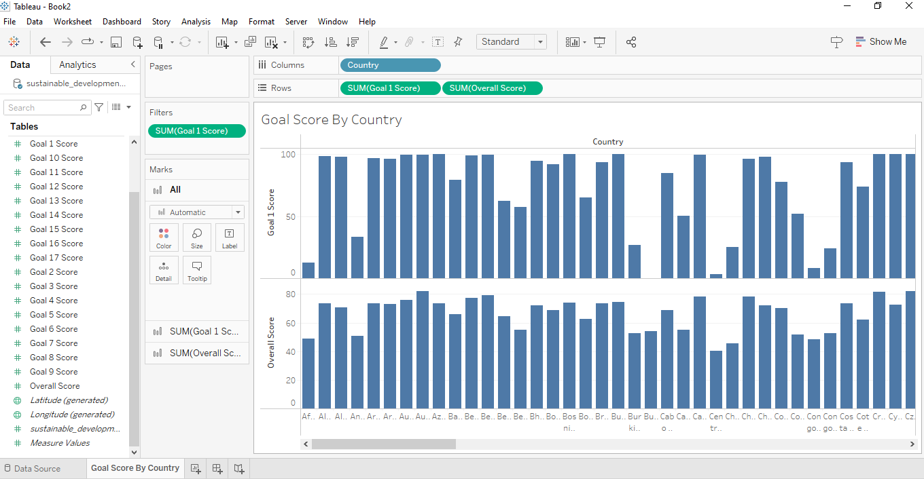

* Click on Dual axis on one of your Columns to combine the both charts.

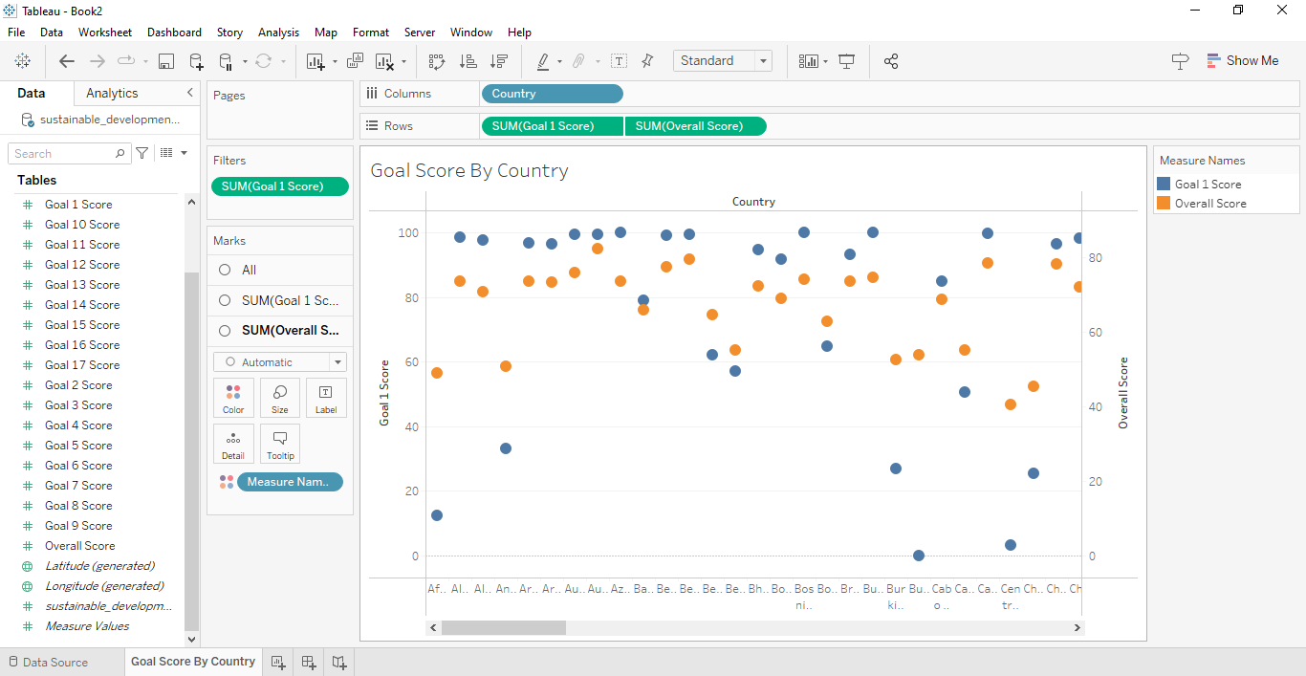

* Change your one of your graphs to Bar graph in Marks Card.

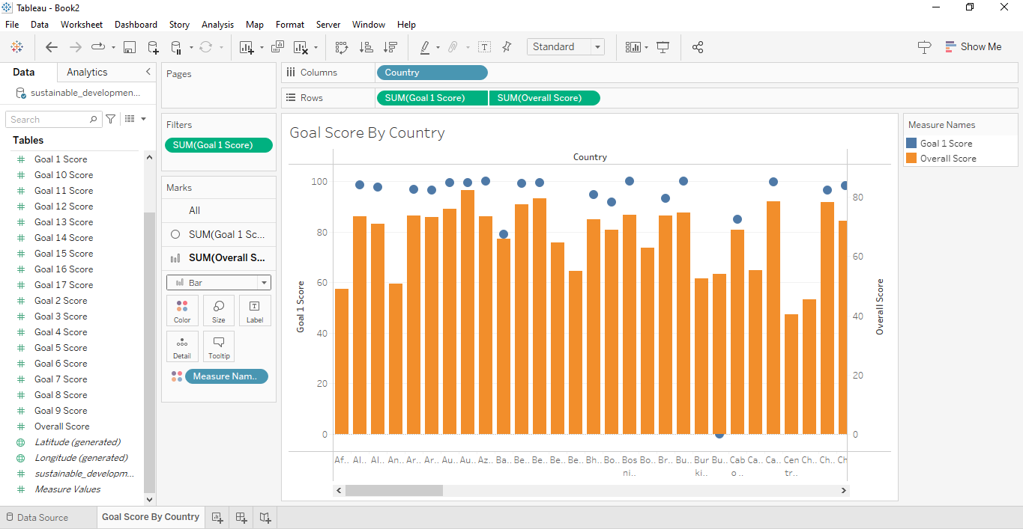

* Choose Country as Filter and Limit Top N countries which is to be displayed.

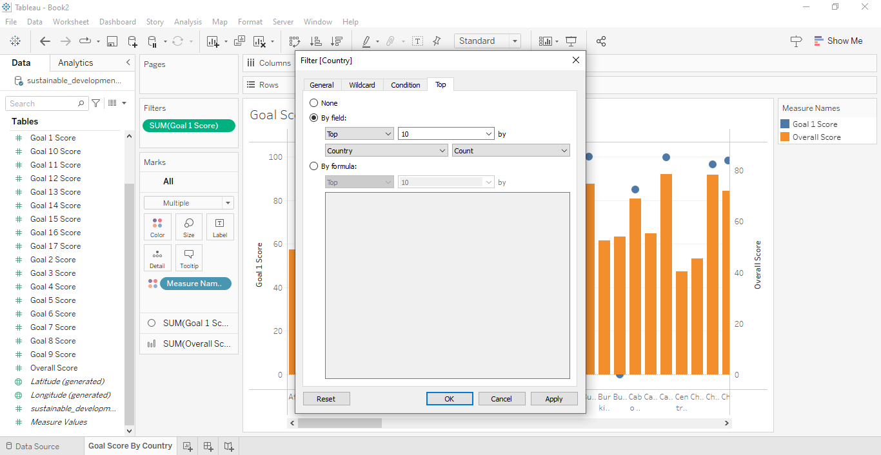

* The Top N Countries are to be displayed.

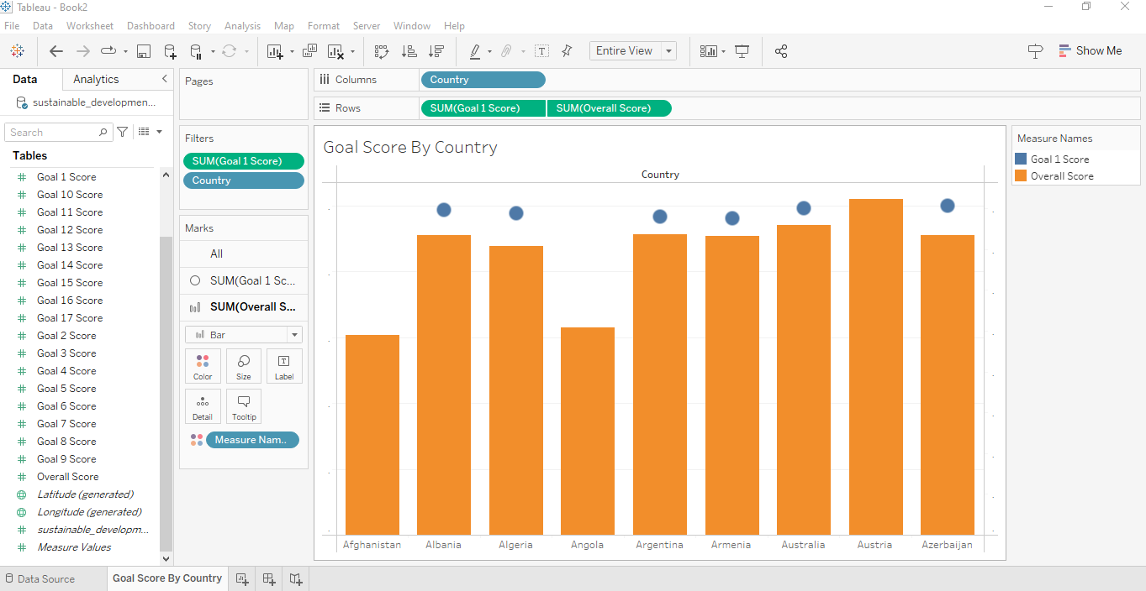

* Drag Country to display the Colour in Marks Card for the visualizations.

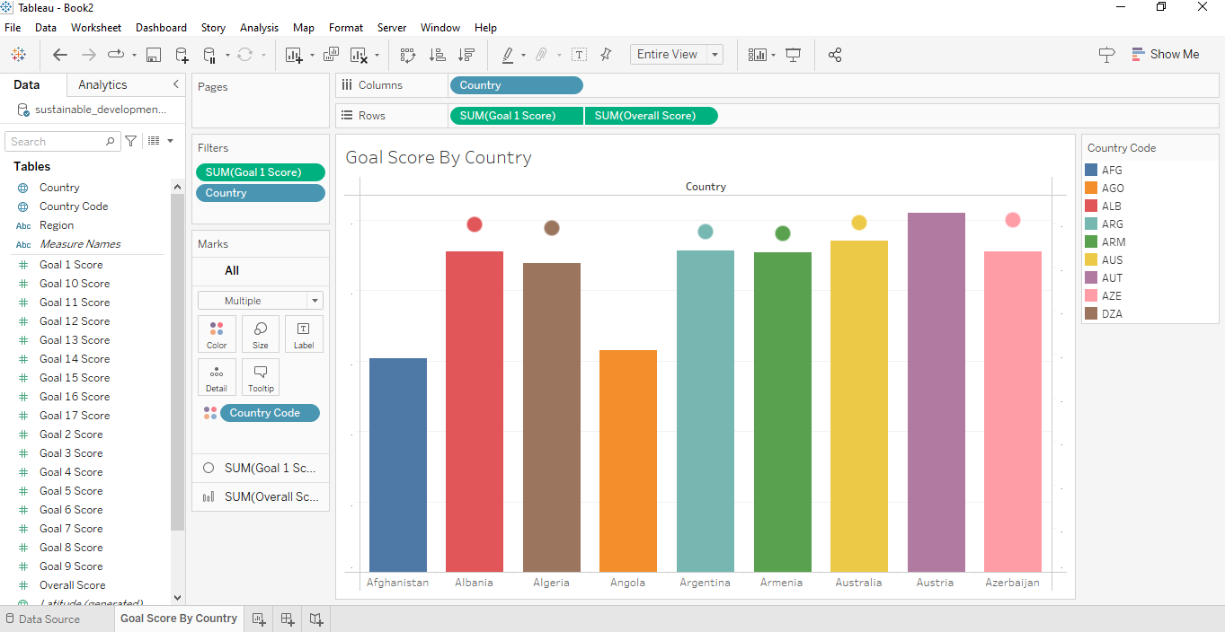

* For one of the other visualization , Choose Shapes in Marks card.

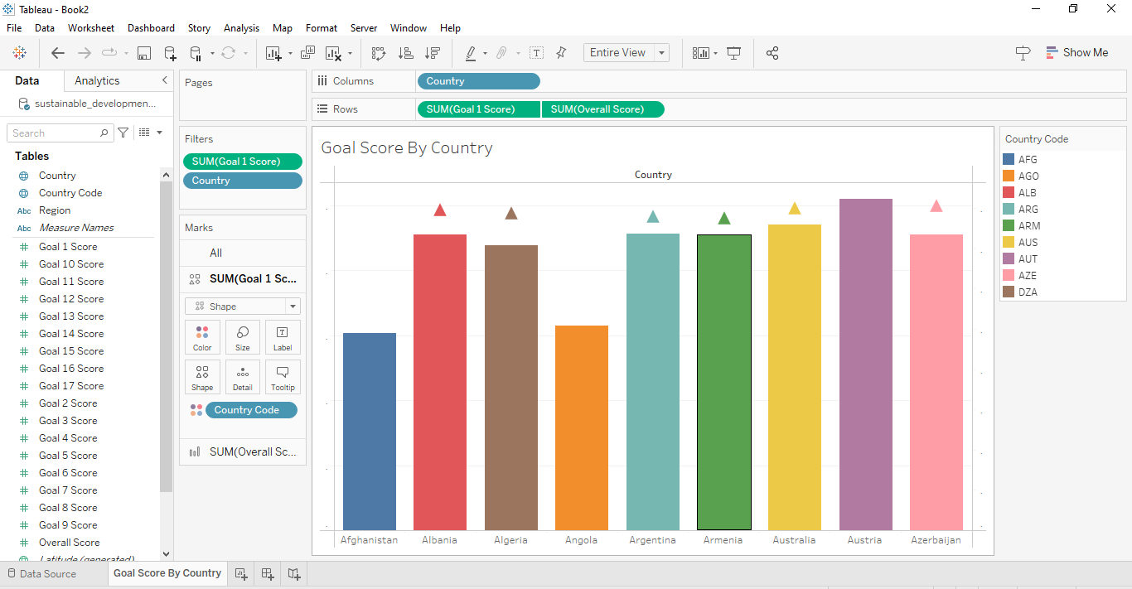

* Choose Shapes as Arrow for the visualization.

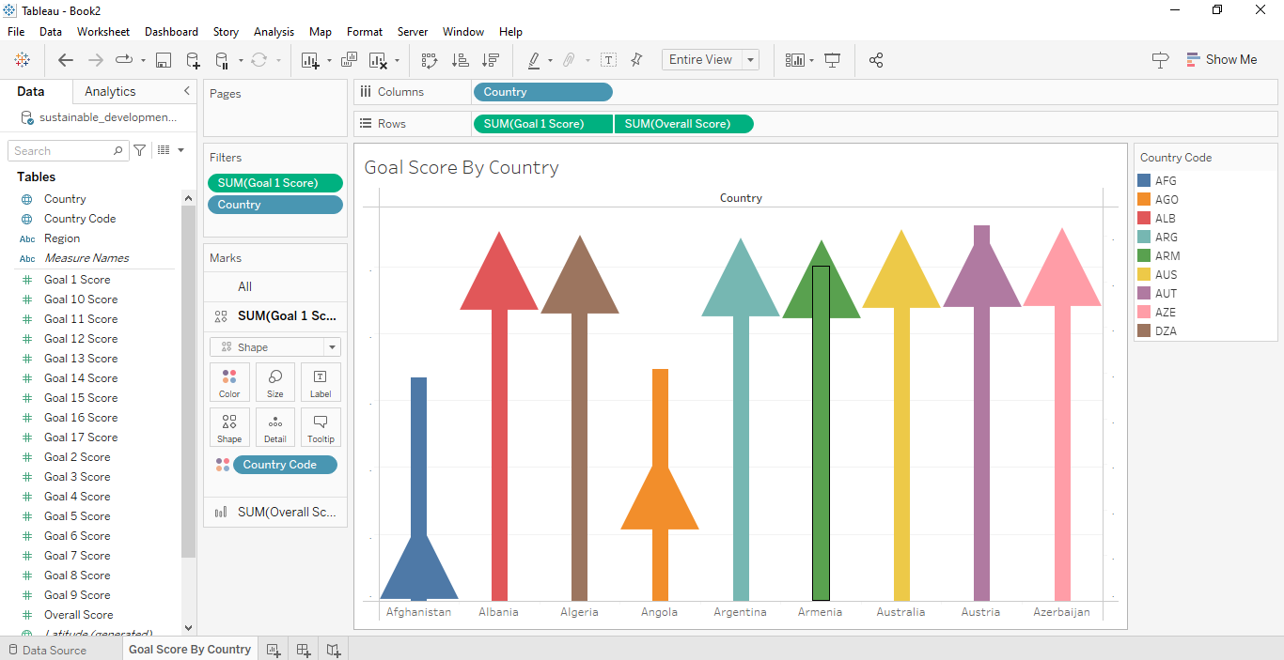

* Drag Goal 1 Score and Overall Score to text in Marks Card to display the values on Visualizations.

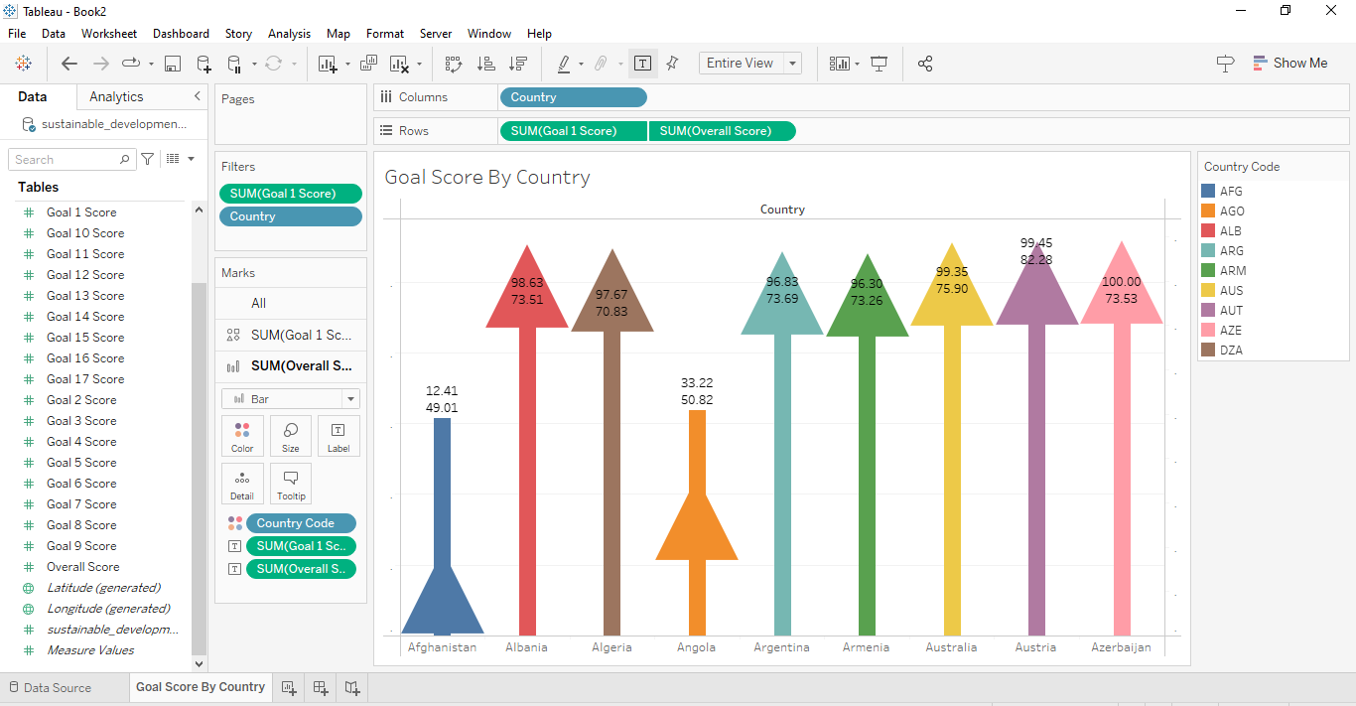

* Format your Background visualization and Shading , Borders and Title of the Header.

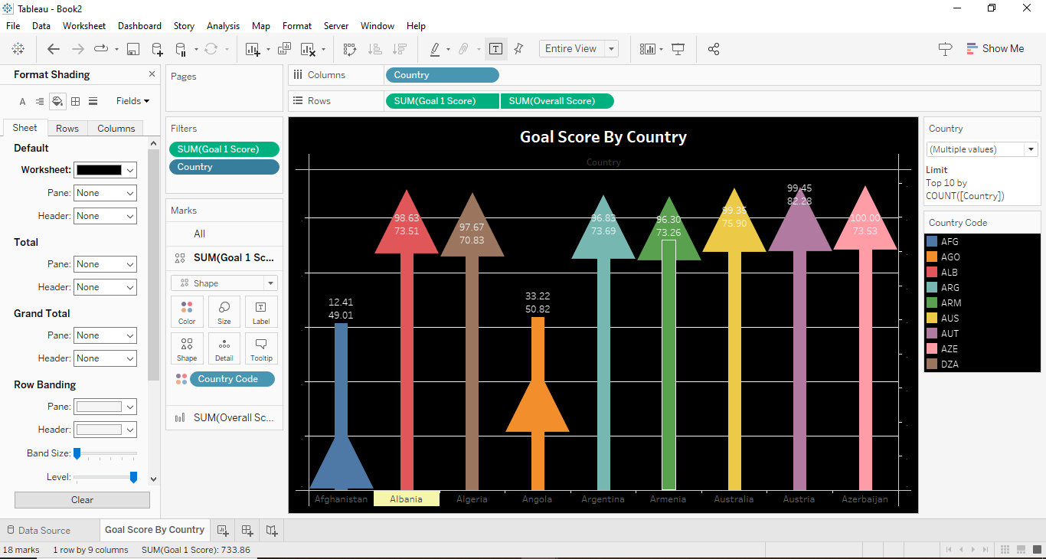

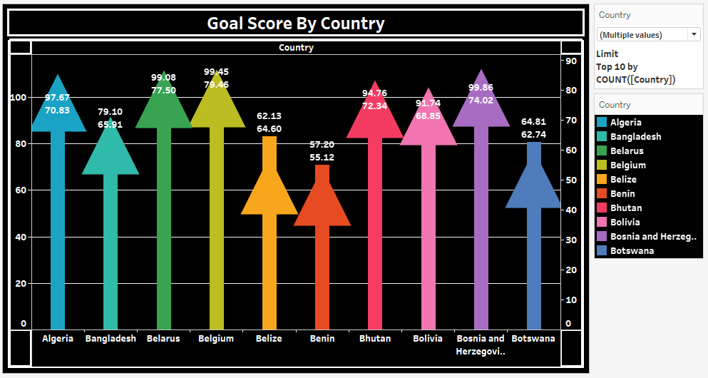

**Insights:**

Insights refer to valuable and meaningful understandings or perceptions gained from analyzing data, information, or experiences. They provide deeper understanding, clarity, or revelation regarding a particular subject or situation.

* Through data visualizations based on Goal Scores by Country, organizations can identify priority areas for sustainable development interventions, directing resources and efforts where they are most needed.
* These visualizations enable benchmarking of progress towards Sustainable Development Goals (SDGs) across different regions and countries, facilitating a deeper understanding of performance and alignment with global sustainability targets

**Conclusions :**

Conclusions are logical deductions or decisions drawn from observations, evidence, or analysis. Conclusions are often based on the findings or results of a study, experiment, or evaluation, and they aim to summarize key insights or outcomes. Effective conclusions should be supported by evidence, logical reasoning, and critical thinking, leading to well-informed decisions or actions.

* Data visualizations based on Goal Scores by Country provide actionable insights for organizations to prioritize sustainable development interventions effectively, optimizing resource allocation and impact.
* Benchmarking progress against Sustainable Development Goals (SDGs) through these visualizations enables organizations to assess their sustainability performance relative to global standards, fostering continuous improvement and alignment with international sustainability targets.
* Leveraging these insights allows organizations to enhance transparency, accountability, and collaboration in their sustainability efforts, driving meaningful progress towards achieving sustainable development objectives on a global scale.